**Github and scrumDo report**

First create account and then sign in with your details

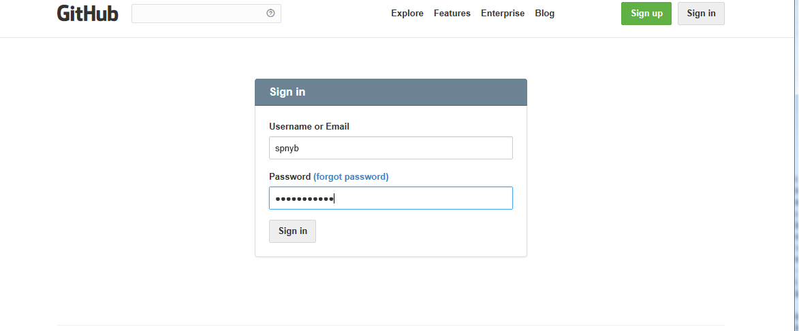

Then u can create repositiories and keep on syncing the details from your pc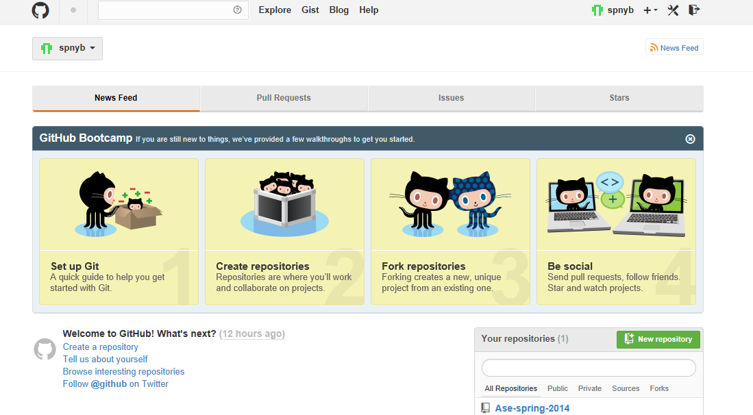

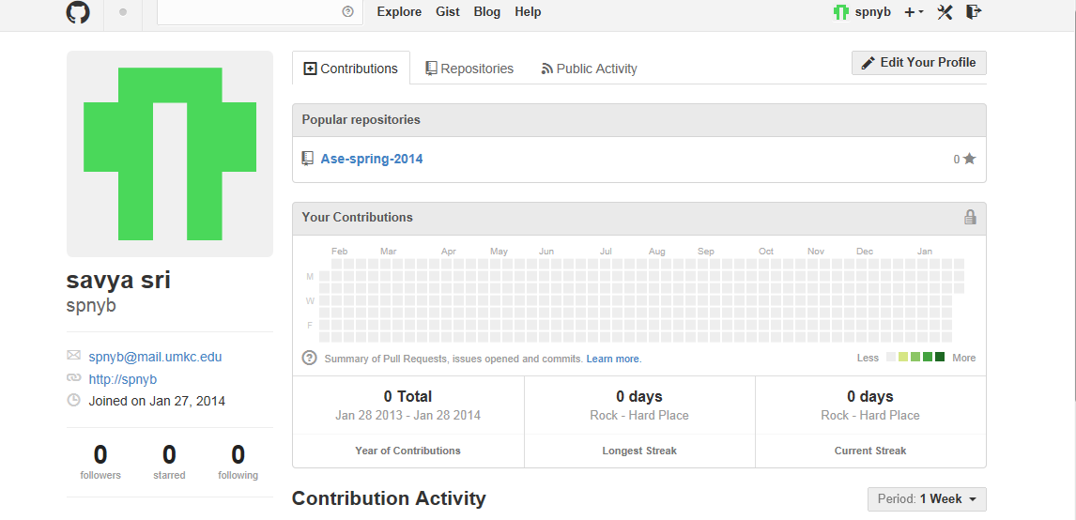

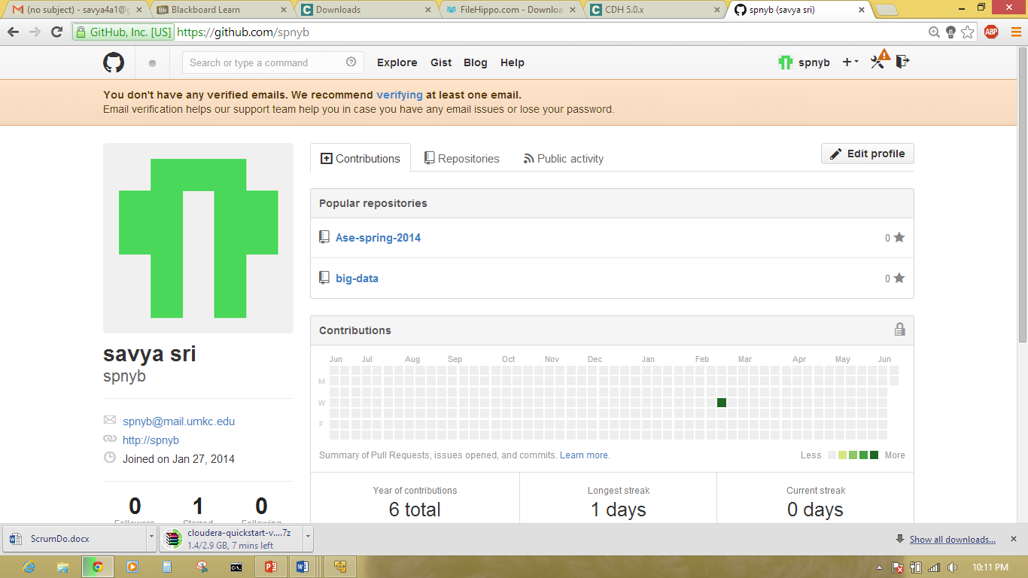

**scrumDo:**

First sign up by creating account and sign in to scrumDo…

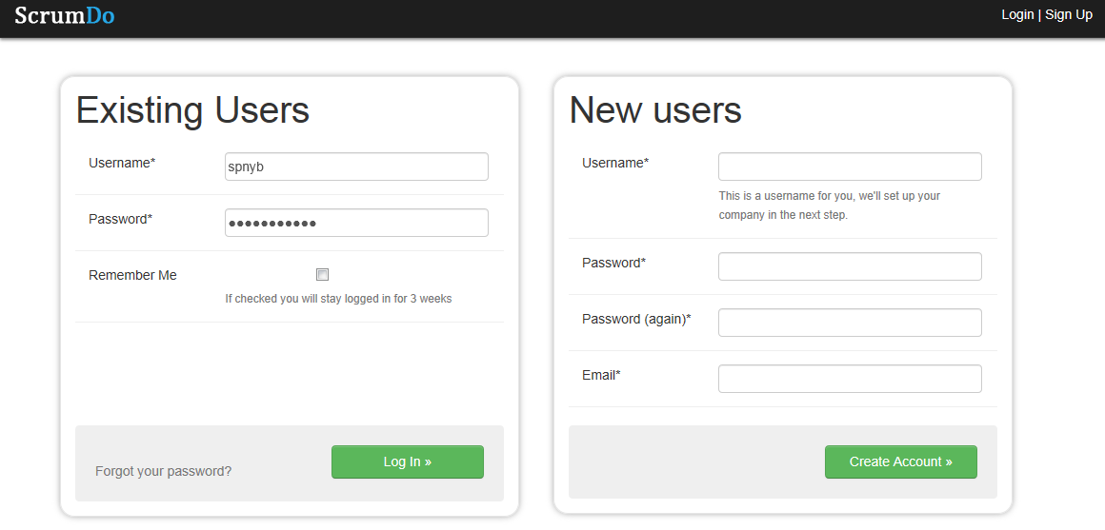

After login into ScrumDo Create organization or click on existing organization…

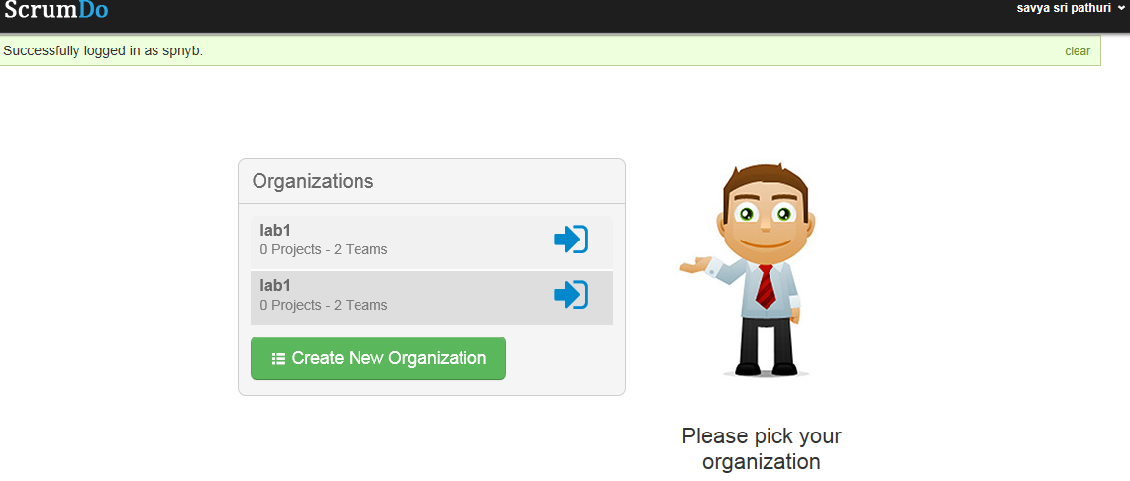

After that project is created and then we can add stories by clicking on add story and we can assign points to that story…